2026 Recreational Crab Creel

Protocols and Equipment

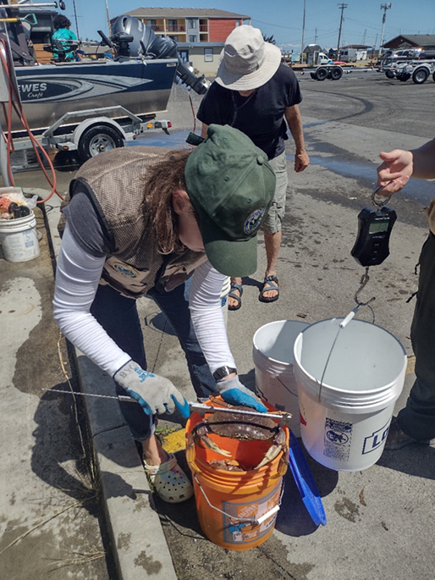
Photo By WDFW

Crab Creel Sampling Protocol:

- Before leaving the office: Check that all your gear is organized and in possession, you have signed out an assigned/available vehicle, and your scales are calibrated using the calibration weights.

- Be at your designated sampling site in a timely manner. Check the schedule to see if you’re assigned to arrive and leave your sampling site at a specific time. If you are scheduled to start your creel at a specific time, it is important you arrive at your site early to ensure you start at your assigned time. Set up your station and have your gear ready at the best spot to easily view and intercept boats as they pull up to the ramp or other access point, but where it will not create congestion.

- Only interview boats and anglers that attempted to go crabbing AND are done crabbing for the day. The definition of a completed trip: Finished crabbing for the day and pulling their boat out of the water at your sampling site (or mooring the boat at your sampling site). Do not proceed to interview boats and anglers that went out only to drop crab gear overnight. You may encounter crabbers from kayak, paddleboard, scuba, or intertidal wading. Please treat these groups the same way you would treat a boat.

- Use the iform app to collect data. Paper forms are available as backup.

- Once you arrive at your creel location and your gear is ready, select “CRAB CREEL FORM 2026” (if using iForms) and complete the header fields:

- Marine Area Assigned. Select the Marine Area you have been assigned to.
- Morning or Afternoon Shift? Select AM or PM.
- Creel Date. Select the date of your creel.
- Creel Start Time. Enter the time your creel started.
- Creel Location. Select your assigned creel location.
- Creeler Name. Select your name.
- Weights in pounds or grams? Select Pounds, Grams, or No Scale. Make sure to use the same scale units for each interview. Do not switch units throughout the day.

Note: If you are sampling a location that is not on the “Creel Location” list select
‘Not-On-List’ and a New Creel Location field will appear. You can type in the new location name into this field. Follow the same steps if you are a new creeler and your name is not on the “Creeler Name” list.

- Intercept each vessel at your location to request an interview either after they have tied up and are proceeding to get their vehicle and trailer or once they have pulled their vessel out of the water. Identify yourself as an employee of the state and WDFW and politely ask them if they have been crabbing today and they have finished crabbing for the day and to take a moment to answer some questions regarding their day crabbing. Be sure to explain what we are doing and why. Direct fishers to your sampling station or the best place to ask questions and record data.

- Avoid excessive discussion with the public if it delays accomplishing your task. If necessary, hand them a business card that contains contact information for the general recreational crab email.
- Boat/Trip information. When you are ready to begin your first interview of the day, select the COLLECT BOAT DATA Subform field. The questions in this subform are focused on collecting trip and catch information from this boat, Catch Record Card information, and biological data on their catch. Most of this information is not unique to each harvester – anyone can answer these questions, but the boat operator is usually best:

- Time of interview: Select the time you started interviewing this boat.
- Is this a motorized vessel? Select Yes or No. Select no if using a kayak, paddleboard, intertidal wading, scuba, etc. Note: If you select ‘No’ a new field will appear where you can type in the method of harvest.
- Number of crabbers on this vessel? Enter the number of crabbers in this party that were attempting to harvest crab. Note: This question still applies to non-motorized vessels or other methods of harvest.
- Number of crab pots fished? Enter the number of crab POTS fished during the current trip (including pots that were lost/stolen).
- Number of other units of crab gear fished? Enter the number of other units of crab gear fished during the current trip (including gear that was lost/stolen). This includes ring nets, star traps, and crab snares.
Note: If ‘0’ is selected for both the number of pots and other types of gear fished an error message will prevent you from submitting the form.
- Soak time in hours? Enter the estimated hours between when their first pot was set and when their last pot was pulled in half hour increments. Examples: 2, 2.5, 0.5, 24 hours.
- Marine Area the crab gear was set in? Select the Marine Area their crab gear was set in.
Note: If setting gear in multiple Marine Areas, select the area the majority of their gear was set in.
- Sub-Area the crab gear was set in? Select the Sub-Area their crab gear was set in.
Note: If setting gear in multiple Creel Areas, select the area the majority of their gear was set in.
- Number of units of crab gear that were lost on this crabbing trip? Enter the total number of units of crab gear that were lost or ‘stolen’ today from this trip. This includes pots, ring nets, star traps.
Now, we need to record the number of Dungeness crab and red rock crab in possession on this boat. If any red rock crab is possessed, please separate red rock crab from Dungeness crab. PLEASE DO NOT BOARD THE VESSEL.

If their crab is stored in a livewell: You can ask them to pull their catch out and divide the catch into as many 5-gallon buckets as needed. If they are not willing to pull their crab out of the livewell, please do not board their vessel or push it any further. Only sample crabs from livewells when the harvester is willing to pull their crab out themselves.

After counting the number of Dungeness and red rock crab in possession, record the following:

- Number of Dungeness crab in possession. Ask how many total Dungeness crab they have retained on the boat. Inspect the catch to confirm the number retained when possible. Enter 0 if no Dungeness crab were kept.
- Number of Red Rock crab in possession. Ask how many total Red Rock crab they have retained on the boat. Inspect the catch to confirm the number retained when possible. Enter 0 if no red rock crab were kept.

Catch Record Card Data. If any Dungeness crabs are in possession on the boat you contacted, you will now be asking questions related to the type of Catch Record Card (CRC) they are using and if any information is recorded on their CRC. There are two types of CRCs used; 1) Paper and 2) electronic (eCRC), which is found on the WDFW app on their mobile phone. The anglers on the boat you are interviewing must be willing (e.g., consent) to participate in questions asked about their CRC. Participation from anglers on questions related to their CRC is voluntary.

- Is CRC data being collected? Enter Yes or No. We attempt to collect CRC information from every boat where Dungeness crab are in possession. Note: If you select “No” a new field will appear asking you to type the reason why CRC data was not collected (see below).
    - Reason why CRC data is not being collected. Type the reason why CRC data is not being collected from this boat.

Next, ask each crabber (those that attempted to catch crab) what type of CRC they are using (see data fields B-G below). Remember, anglers are not required to answer questions regarding their CRC. In each field, tally the total number of CRCs being used in each category.
- Total crabbers using ‘PAPER CRC’: Tally this number.
- Total crabbers using ‘PAPER CRC’ that kept Dungeness Crab: Tally this number
- Total crabbers using ‘ELECTRONIC/MOBILE CRC (eCRC)’: Tally this number.
- Total crabbers using ‘ELECTRONIC/MOBILE CRC (eCRC)’ that kept Dungeness crab: Tally this number
- Total crabbers with ‘NO CRC’ type in possession: Tally this number. The individual must openly report that they do not have a CRC in possession.
- Total crabbers with ‘UNKNOWN CRC’ type (refused to answer, not present, etc.): Tally this number. This could include any crabber that refused to answer questions, left during the interview, or any other situation where their CRC type could not be determined.
NOTE: The sum of the values from data fields B, D, F, and G must equal the value input for the ‘number of crabbers on this vessel’ (reported earlier on the form).
PAPER CRCS ONLY: Ask to view the PAPER Catch Record Cards on this boat from PAPER CRC holders that kept at least 1 Dungeness crab. Ask each question and record the following:

- Are you checking catch on paper CRCs?: Select ‘Yes’ or ‘No’. Note: If you select “No” a new field will appear asking you to type the reason why paper CRCs were not checked.
    - Type the reason why you did not check paper CRCs for this vessel. Type the reason here.
- Total Number of PAPER CRCs checked. Ask if you can confirm/check the number of crab recorded on their paper CRC and ENTER the total number of paper CRCs checked from crabbers with a paper CRC that kept Dungeness crab that consent to showing their paper CRC . It is voluntary for harvesters to show their paper CRC.
- Total Number of Crab Recorded on PAPER CRCs. Enter the total number of crabs recorded across all checked paper CRCs from this boat. Use a handheld counter if it helps to tally the total number of recorded crabs. For an individual paper CRC, if there is a discrepancy between the number of crabs marked (X) and the number of crabs totaled, use the highest number between the two. Note: If no crabs are recorded across all paper CRCs, please enter 0 crabs recorded.
- Are any paper CRCs being used for the incorrect season (winter CRC being used during the summer season; summer CRC being used during the winter season). Enter Yes or No. The CRC valid date is located at the top of the paper CRC (durable stock). Print at home CRCs state summer vs. winter.
- Count of paper CRCs being used for the wrong season. Enter the total number of CRCs that are being used during the wrong season.
Mobile/Electronic CRCS ONLY: Ask to scan the barcode located on the mobile Catch Record Card from those crabbers that caught at least 1 Dungeness crab. Ask each question and record the following:

- Total number of eCRC holders that do not consent to a barcode scan. If any anglers using an eCRC that kept Dungeness crab do not volunteer to barcode scans, enter the total number here. An angler’s participation in having their barcode scanned is voluntary.
- Total number of eCRC holders with technical issues preventing a CRC scan. Enter the total number of eCRC holders that are having technical issues related to accessing their mobile CRC. Examples may include a dead phone, lost phone, broken phone, not able to login, app not working properly, etc.
- Scan all barcodes. For each individual eCRC, scan the barcode located on their myWDFW app. For privacy, barcodes will be ‘masked’, so you will not see the last 6 digits.

Barcode location: MyWDFW app - home page – upper right corner - select the symbol that looks like a QR code – barcode will appear – scan code by hovering ipad/iphone screen over the barcode.

Important Note: DO NOT scan any barcodes until ALL prior information has been recorded. If any of these numbers in the prior questions are changed, the scans will be deleted, and you will need to re-scan them.
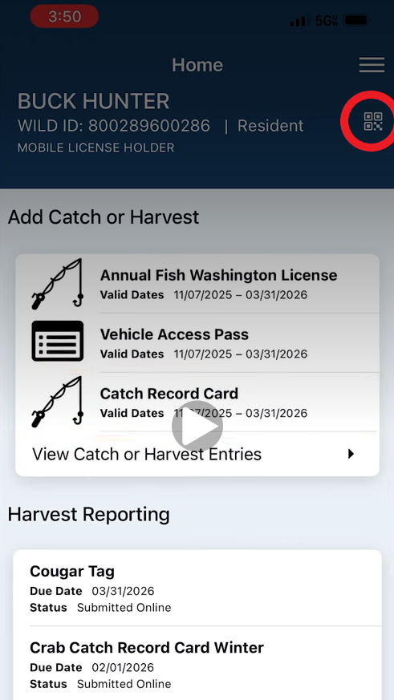

Collecting Weight Data

The next set of questions will only appear if Dungeness and/or Red Rock crab are in possession on the vessel being interviewed. You should target approximately every 4th boat (25% of your interviews in a given day) to obtain a weight sample of Dungeness crab and Red Rock crab retained. Do not collect weights on ‘backed’ crab, where the carapace (shell) has been removed. Sample all crabs from the intercepted boat (i.e., do not sub-sample their catch) and treat Dungeness crab and Red Rock crab separately when collecting the information below.

Dungeness Crab:
  - Are you collecting a weight measurement of their Dungeness crab? Select Yes or No.
  - Enter the number of Dungeness Crabs Weighed. Enter the total number of Dungeness crabs included in the weight measurement.
  - Dungeness Crab Batch Weight #1: Enter the total weight for this batch (e.g., bucket). Ensure the bucket with the crab is completely drained of water before taking a weight. Tare your scale, and/or make sure to subtract the weight of the bucket so it is not included in the recorded weight. Ensure you are in the correct units!!
  - Dungeness Crab Batch Weight #2 (If needed): Enter the total weight for this batch.
  - Dungeness Crab Batch Weight #3 (If needed): Enter the total weight for this batch.
  - Dungeness Crab Batch Weight #4 (If needed): Enter the total weight for this batch.
  - Dungeness Crab Batch Weight #5 (If needed): Enter the total weight for this batch.
Red Rock Crab:
  - Are you collecting a weight measurement of their Red Rock Crab? Select Yes or No.
  - Enter the Number of Red Rock Crabs Weighed. Enter the total number of red rock crab included in the batch weight.
  - Red Rock Crab Batch Weight #1: Enter the total weight for this batch (e.g., bucket). Ensure the bucket with the crab is completely drained of water before taking a weight. Tare your scale, and/or make sure to subtract the weight of the bucket so it is not included in the recorded weight. Ensure you are in the correct units!!
  - Red Rock Crab Batch Weight #2 (If needed): Enter the total weight for this batch.

Collecting Red Rock Crab Biological Data

The next question will only appear if Red Rock crab are in possession on the vessel being interviewed. You should target every 4th boat for checking retention of female red rock crab (when red rock crab weights are being taken). Do not collect this data on ‘backed’ crab, where the carapace (shell) has been removed. Sample all crabs from the intercepted boat (i.e., do not sub-sample their catch) when collecting the information below.

- Checking Biological Data of Red Rock Crab? Select Yes or No. Select ‘Yes’ if you are checking for retention of female red rock crab.
- Number of Red Rock Crab Sampled for Biological Data. Enter the total number of red rock crab being sampled.
- Number of Female Red Rock Crab in Possession. Select the total number of female red rock crab retained. Note: Leave this field blank if you were not able to check for female. If you select 5+ female red rock retained, a new field will appear asking you to manually enter the number greater than 5.

- When you are finished sampling a boat, select “Done” at the bottom of the form (do not hit “save” in the upper right-hand corner). You will now be taken to the record view page.

Select “+” to start an interview with the next boat. If you are done interviewing boats for the day, hit the “” in the upper left corner to return to the “Header” form.

- Once you arrive at the header form, complete the remaining header fields: Creel End Time. If you are ready to submit the form, select the READY TO SUBMIT toggle and hit “Done”. Depending on your settings in iforms, your interview data should automatically upload to the database and be deleted on submission.

- If the person being interviewed becomes abusive or combative then end the interview...your safety is top priority. Leave the scene and contact a supervisor on your list of telephone contacts when it is safe to do so.

- If you are using paper forms, please enter the information from any paper copies after your survey into the iForm. If you are unable to do so, then scan them OR photograph them and email them. Make sure the images of data sheets are clear and complete. If any other questions arise use a cellular phone or public phone to contact a supervisor for instructions on how to proceed.

